Chương 4

Bài 1 slide 27

Kết quả demo:

Bài 2 slide 28

Kết quả demo

Bài 4 slide 28

Kết quả demo

Bài 6 slide 28

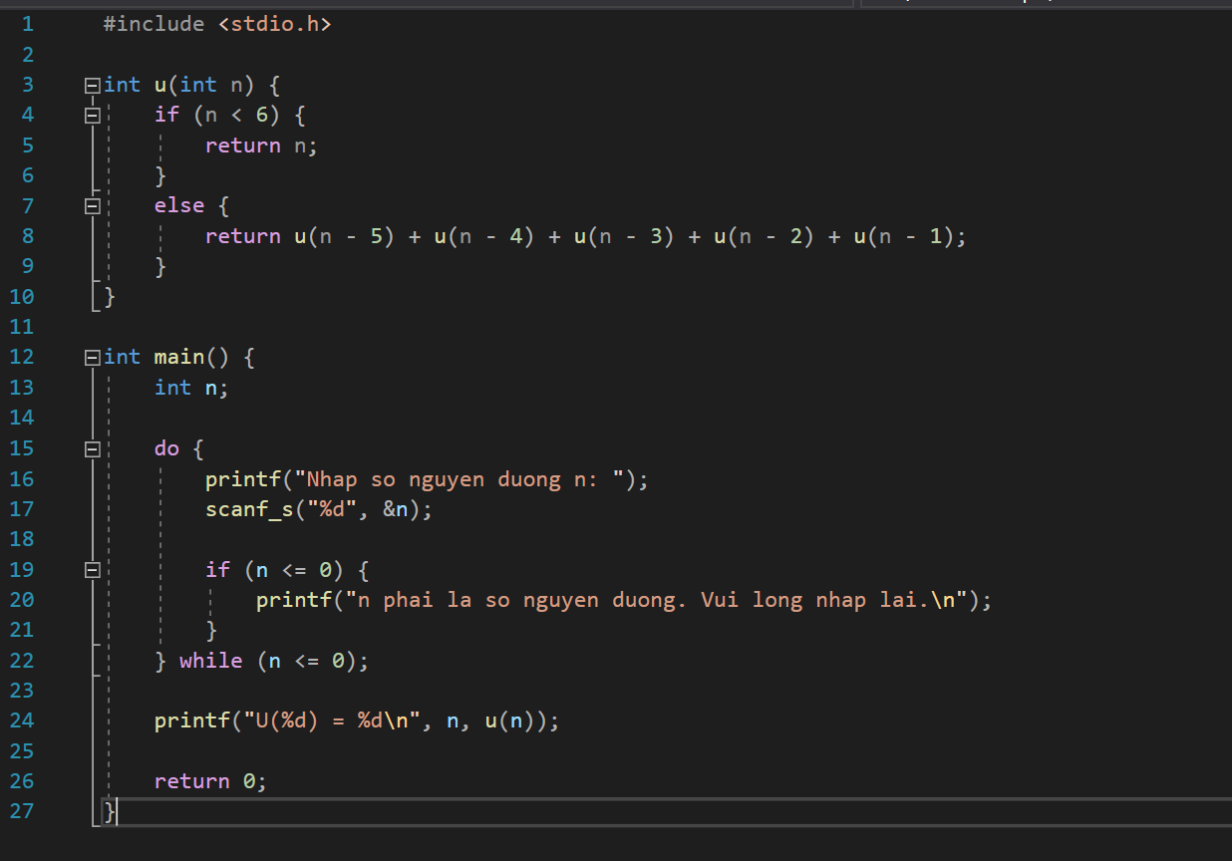

Kết quả demo

Bài 8 slide 29

Kết quả demo

Bai 10 slide 29

Kết quả demo

Bài 12 slide 30

Cách 1:

Kết quả demo cách 1

Cách 2:

Kết quả demo cách 2

Bài 14 slide 30

Kết quả demo

Bài 16 slide 30

Cách 1:

Kết quả demo cách 1

Cách 2:

Kết quả demo cách 2

